DevOps Internship || Linux Commands
List Commands:

ls ---- Showing all List.
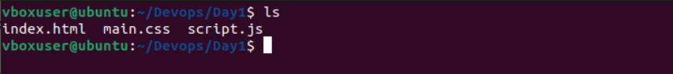

ls -la -- it showing all hidden files.
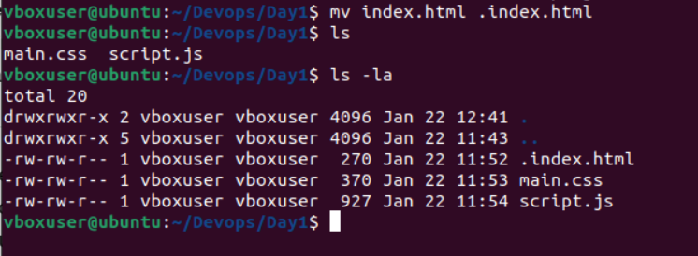

ls -lh -- it showing all file size in human readable format.
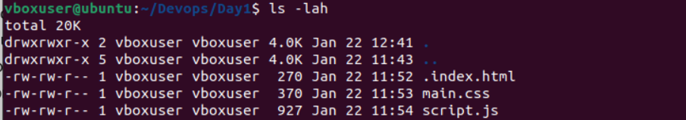

ls -ls --- How much space a file actually occupies on the disk.
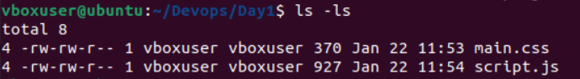

ls -lstr --- Show a detailed list, include disk block usage, sort files by time, and reverse the order.

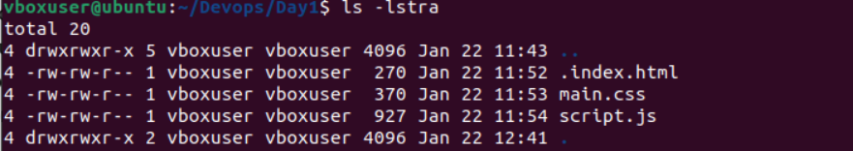

Move Command
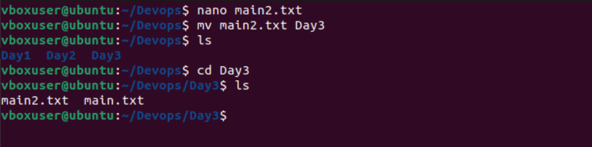

mv (Move Command) – Moves or renames files and directories from one location to another.

Copy Command
Copy file to folder – Copy file from Home dir to Particular Dir
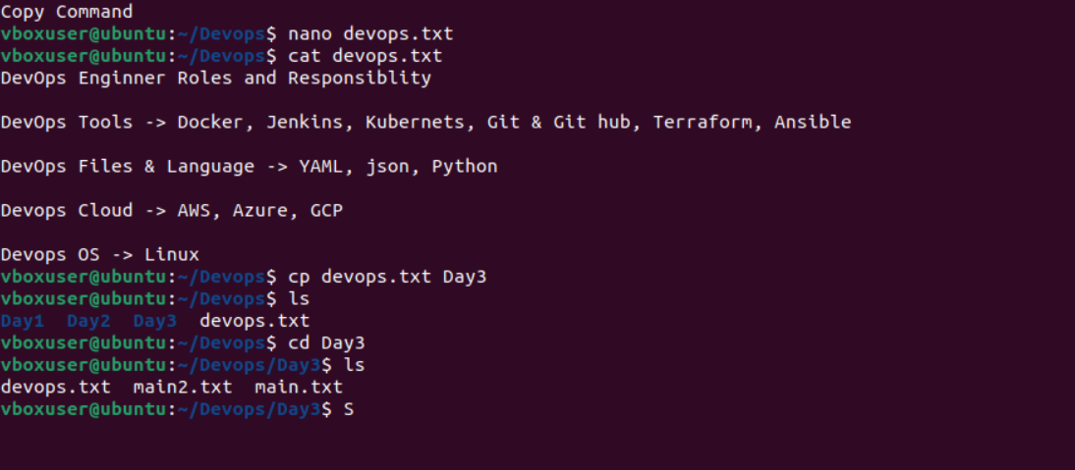

Copy File Folder to Folder – Copy file content one directory to another
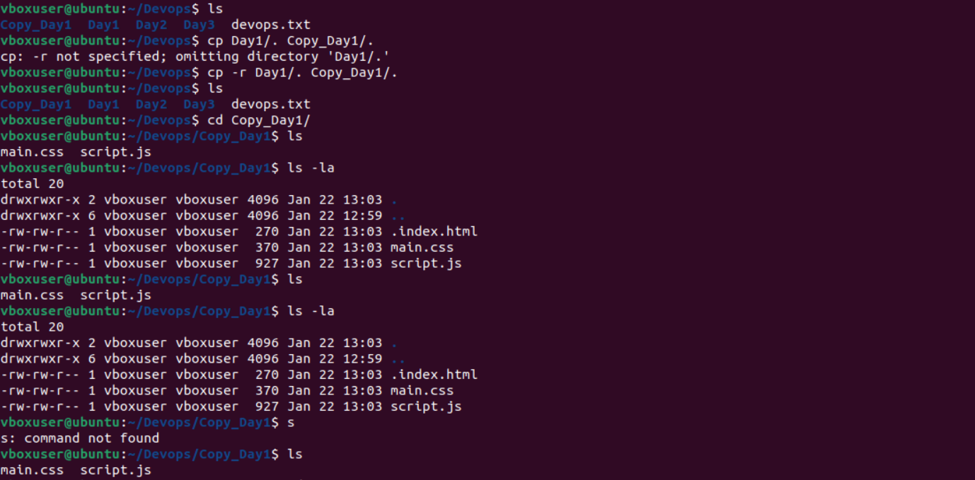

Content File to File - Copies the contents of one file into another file.
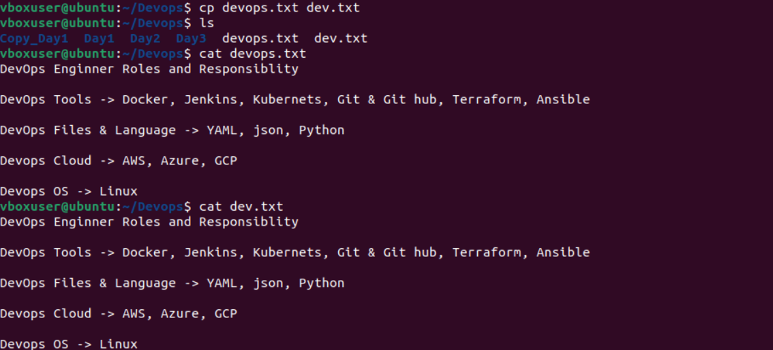

Home dir to File Path - Copies files from the home directory to a specified path.
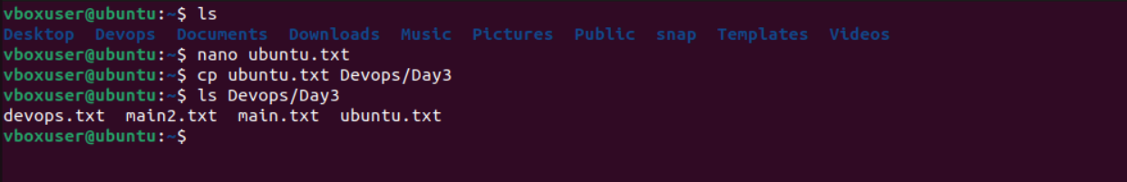

Remove File - Deletes a file permanently from the system.

Remove Dir - Deletes a directory and its contents recursively.

View:
cat - Displays the contents of a file on the terminal.
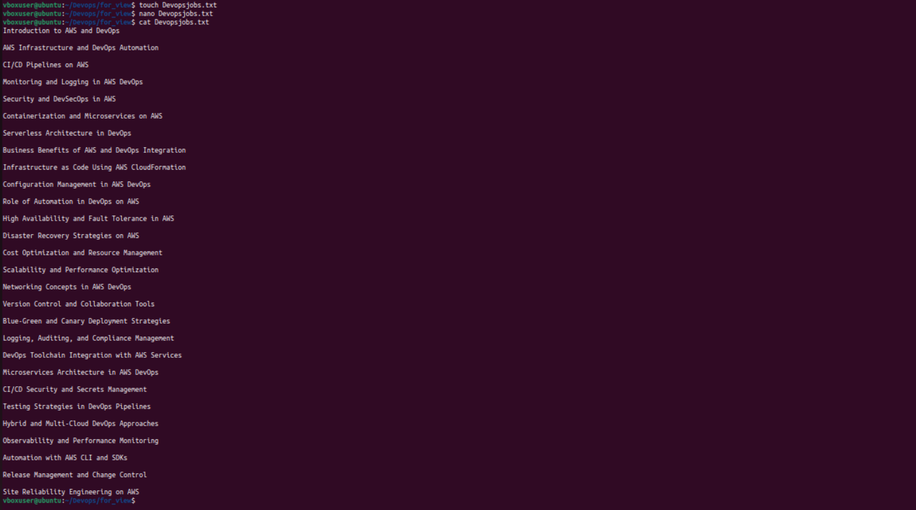

Grep - Searches for a specific pattern or word inside files.
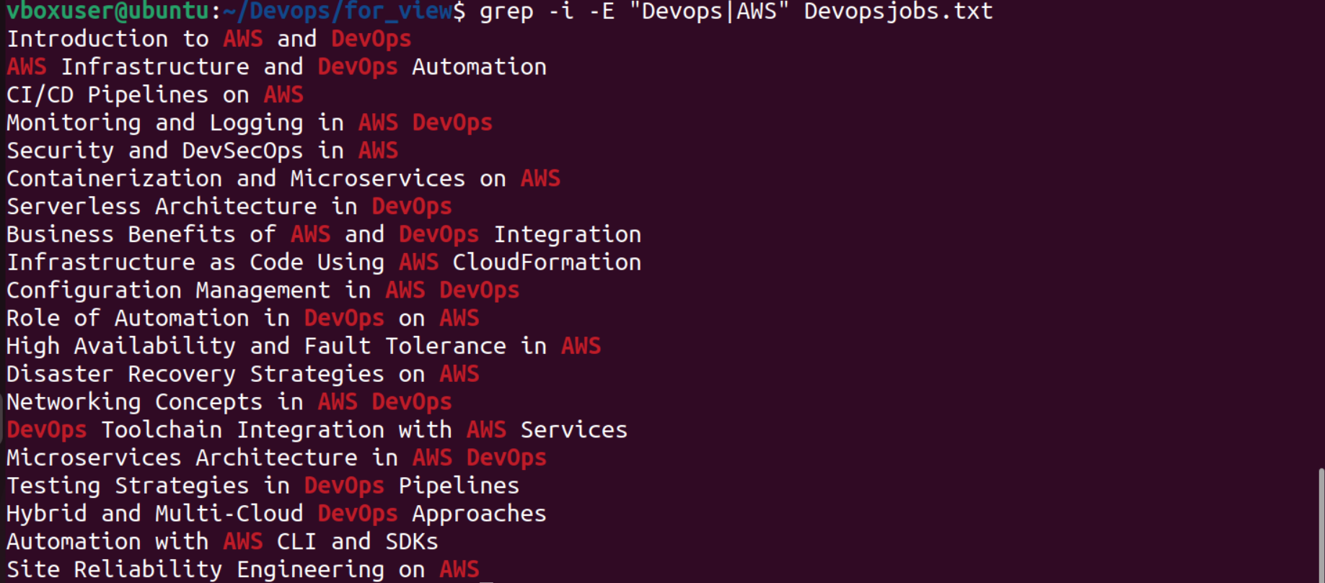

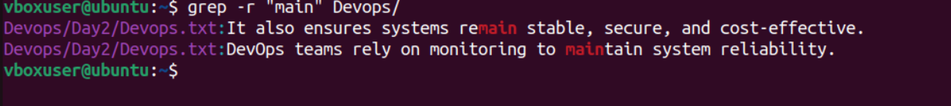

Cd ~ – Navigates to the user’s home directory.
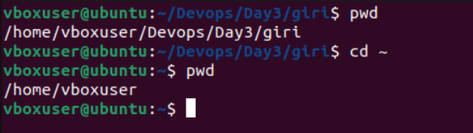

. – Current Dir File - Represents the present working directory.
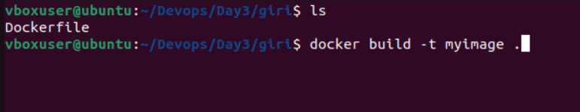

.. – Parent file – Represents the parent directory of the current location.
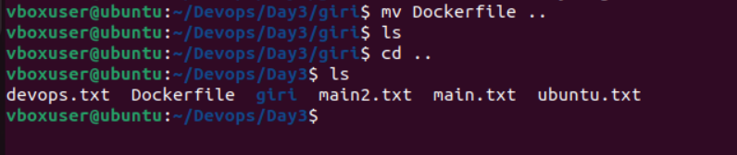

Head and tail command

head – Displays the first few lines of a file.
tail – Displays the last few lines of a file.
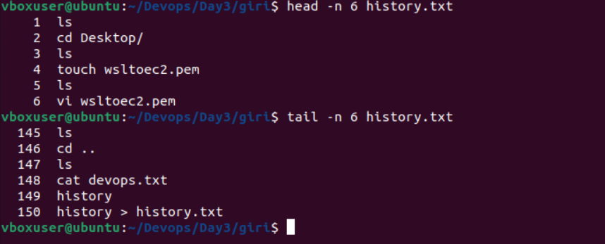

Grep and head/tail Command
grep with head/tail – Filters searched output and limits the result to top or bottom lines.
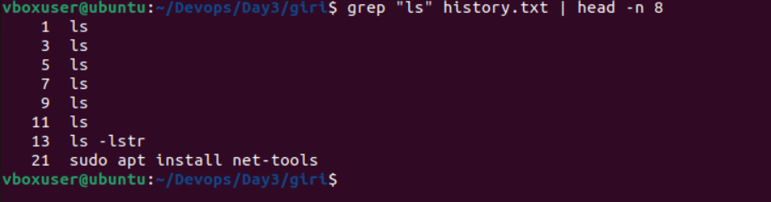

find and grep pipe – Searches files using find and filters results using grep
Find and grep pipe
